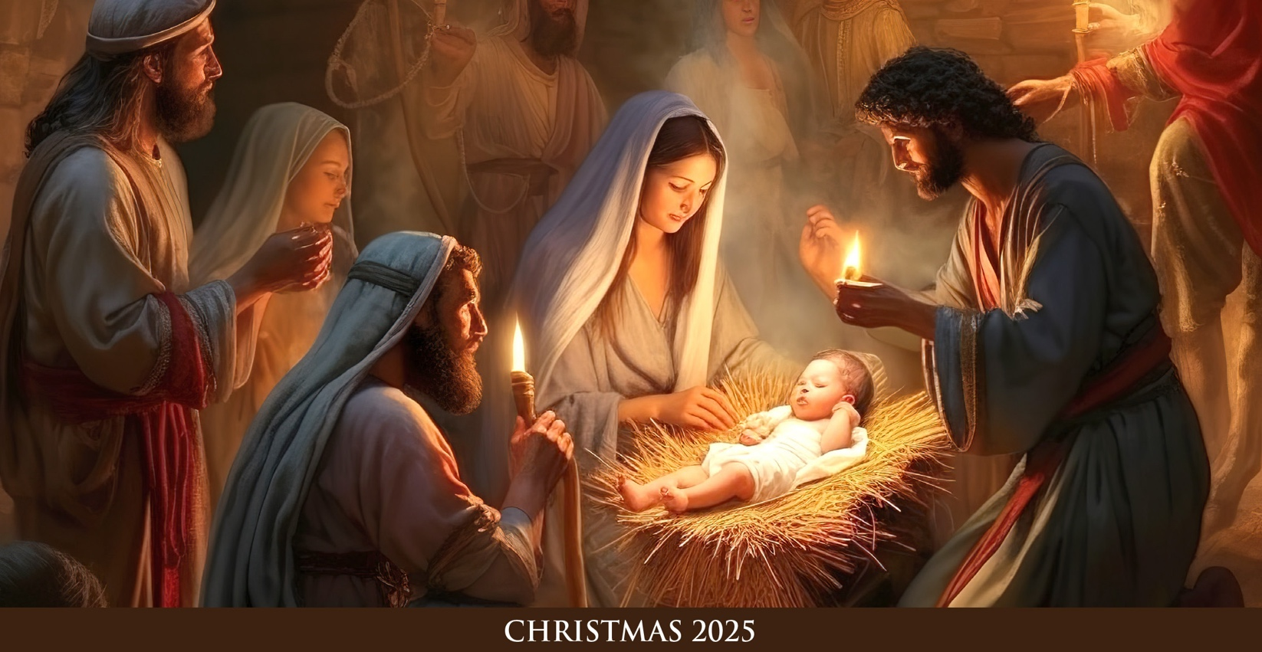

Hello Everyone —
After a season of watching and waiting, at the Christmas Midnight Mass we hear the wonderful words:
“The people who have walked in darkness have seen a great light.”
Isaiah 9:1
Can you imagine for a moment being a part of the nativity scene? Forget the sanitized view born from nativity plays — beautiful though they are — the stable is a dark and muddy place. It is quaint and almost forgotten. In this humble place a cry pierces the night: an infant is born and swaddled in rags. For all intents and purposes, this could be any baby in any place in the world. But what unfolds in this scene is a miraculous birth that forever changed the world. The Savior of the world is not a king born in a grand palace with finery, but an infant born of poor parents in a modest stable.
It’s hard for us to imagine who would take offense at a baby born in a manger — a defenseless infant in such a lowly place. Yet even then, some did. And still today, many turn away. But God holds nothing back. He enters our darkness, our “stables,” our forgotten places. Jesus comes to us not as a princely dignitary who rules with power and decree, but as one meek and humble of heart, bringing light to our darkness and inviting us into a life of humility, gentleness and grace.
Through his miracles and mercy, Jesus shows us that everyone — especially those pushed to the margins — is worthy of dignity and love. He continues to invite us to see his presence: in the beauty of creation, in the love of family and friends, and most profoundly, in the presence of Christ in the Eucharist.
My hope and prayer for you this Christmas is that your heart will be filled with the light of God’s inbreaking love — that the eternal Son may shine into your life, your heart and your family. May his light, which no darkness can overshadow, fill you with peace, joy and freedom that the world cannot give.
May God bless you, and Merry Christmas!
Most Reverend Jeffrey S. Grob
Archbishop of Milwaukee

