OFFERTORY COLLECTION &
CASH HANDLING PROCEDURES
Tamper-Evident Bag Procedures, Chain of Custody & Counting Team Requirements
Based on the Parish Financial Management Manual (PFMM) of the Archdiocese of Milwaukee

1. Purpose
This document provides standardized procedures for handling offertory collections, from the moment money is collected through the counting process and bank deposit. These procedures are required by the Archdiocese of Milwaukee Parish Financial Management Manual (PFMM) to safeguard parish assets and maintain a clear chain of custody.
All parish staff and volunteers involved in the collection, counting, or deposit process should read and follow these procedures.

2. Chain of Custody — Overview
The chain of custody ensures that every dollar collected can be accounted for from the pew to the bank. The process is:
• Step 1 — Collection: Ushers collect the offertory and immediately place it in a tamper-evident bag.
• Step 2 — Secure Storage: The sealed bag is placed in the parish safe as soon as possible after the Collection.
• Step 3 — Pickup for Counting: An authorized person retrieves the bags from the safe for counting. Bag numbers are verified against the Tamper-Evident Bag Log before bags are opened.
• Step 4 — Counting: At least two unrelated counters open the bags, count the contents, and prepare the bank deposit. The counted deposit is placed in a new bag for deposit.
• Step 5 — Bank Deposit: A designated person (not involved in counting or bookkeeping) delivers the deposit to the bank.
PFMM: Section 5.6.1 — "A bag log is required to document the chain of custody of offertory collections from the point of collection through counting and deposit."

3. Tamper-Evident Bags — What They Are & How to Use Them
Tamper-evident bags are specially designed deposit bags with security features that show visible evidence if the bag has been opened or tampered with. They come pre-numbered and include a tear-off receipt at the top.
Below are examples of two common styles of tamper-evident bags used in parishes:


Example 1: Tamper-evident bag showing the tear-off receipt at top, bag number, and security seal area.

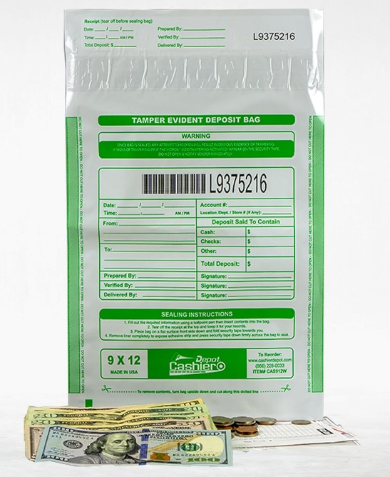
Example 2: Tamper-evident deposit bag with tear-off receipt portion visible at top.

4. The Tear-Off Receipt — Why It Matters
Each tamper-evident bag has a perforated tear-off receipt at the top. This receipt contains the same bag number as the bag itself. This is a critical part of the chain of custody:
• Before sealing the bag, fill out all required information on the bag (date, time, amount, prepared by, etc.) using a ballpoint pen.
• Tear off the receipt at the perforated line before sealing.
• The tear-off receipt must be saved and kept with the deposit documentation. This provides proof that the bag was used, sealed, and its contents are accounted for.
• The receipt matches the bag number, so if any question arises about a deposit, you have a paper trail linking the receipt to the sealed bag.
Never discard a tear-off receipt. It is part of the permanent deposit record.

5. Sequential Bag Numbering
Tamper-evident bags are pre-printed with sequential numbers. Parishes must use bags in numerical order. This makes it possible to identify immediately if a bag is missing.
• Record every bag number on the Tamper-Evident Bag Log (see attached template).
• Before opening bags for counting, verify that bag numbers are sequential and match the log entries.
• If a number is missing from the sequence, investigate and document the reason before proceeding.
PFMM: Section 5.6.1 — "Ushers must record the bag number on the log, and counters who receive the collection must verify that the bag numbers are sequential."

6. Voided or Damaged Bags
If a tamper-evident bag is opened by mistake, damaged, or otherwise cannot be used, it must still be accounted for:
• Write "VOID" on the damaged or opened bag.
• Record the voided bag number on the Tamper-Evident Bag Log in the "Voided / Damaged Bag #" column with an explanation in the Notes column.
• Retain the voided bag (or its remains) and keep it with the deposit records. Do not discard it.
• Transfer the contents to the next bag in sequence and record the new bag number on the log.
This procedure ensures that no bag number is unaccounted for and prevents any appearance of missing funds.

7. Counting Team Requirements
The PFMM establishes clear requirements for who may serve on counting teams and how teams must be structured:
• At least two unrelated persons must be present whenever cash is counted.
• Related individuals (spouses, family members) may not serve on the same counting team.
• There should be an odd number of counting teams, and teams must be rotated on a regular basis.
• No team should count during the same week each month.
• Trustees may not serve as counters due to their fiduciary responsibilities.
PFMM: Section 5.6.9 — "Individuals performing the counting must be rotated on a regular basis. There should be an odd number of teams consisting of at least two unrelated persons on each team."
PFMM: Section 5.6.2 — At least two unrelated individuals must be present whenever cash is counted. A trustee may not serve as a counter because of their fiduciary responsibilities.

8. Segregation of Duties
Proper segregation of duties is essential to protect parish assets and prevent errors or misappropriation:
• Any individual with access to bank accounts or QuickBooks should not count money or handle cash.
• The person who makes bank deposits must be different from the person who records deposits in QuickBooks.
• The bookkeeper must not participate in counts or deposits.
• If staffing is limited, use volunteers for counting teams so that no single individual controls multiple steps in the receipt and recording process.
PFMM: Sections 3.1 & 3.4 — Financial duties must be separated to reduce the risk of error and misappropriation.

9. Tamper-Evident Bag Log Template
A printable Tamper-Evident Bag Log template is available on our website (Excel format). The log includes the following columns:
• Date
• Mass / Collection Time
• Bag #
• Usher Initials
• Picked Up By
• New Bag # (After Counting)
• Voided / Damaged Bag #
• Deposited By
• Notes
The log should be maintained for each collection cycle and retained with the parish financial records per Archdiocesan retention requirements.

10. Quick Reference — PFMM Sections
PFMM Section | Topic
3.1 & 3.4 | Segregation of financial duties
5.6.1 | Tamper-evident bag log and chain of custody requirements
5.6.2 | Minimum of two unrelated counters; trustee prohibition
5.6.9 | Counting team rotation; odd number of teams; unrelated members
5.9.7 | Bank signature authority; bookkeeper/business manager may never be a check signer

For the complete Parish Financial Management Manual, visit:
https://intranet.archmil.org/Resources/ParishFinancialManagementManual.htm

