EASTER 2026

Do not be afraid. Go tell my brothers to go to Galilee, and there they will see me.
- Matthew 28:10

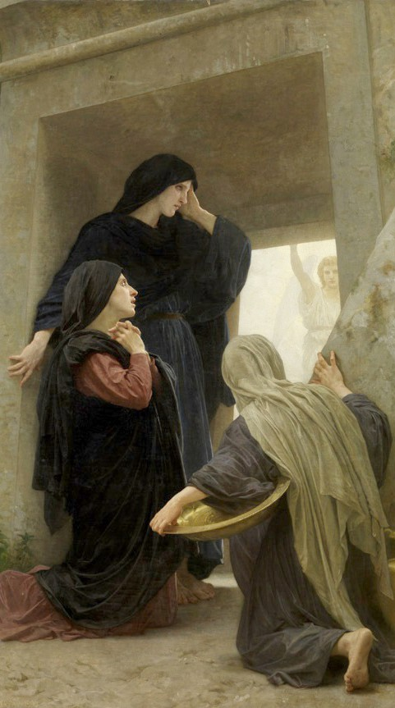
Hello Everyone,
In Jesus’ first words to the women at the tomb, he says three things we can take to heart.
First, he says, “Do not be afraid.” We all have something we’re afraid of. Jesus’ ultimate triumph over sin and death should cast away all our fears and worries. Of course, this is much harder in practice than in theory, but we are reminded to cling to God’s promises and not be afraid.
Then he tells them to “go” and tell. The women at the tomb become the first evangelists, and this is the call to us as well. Go! Go tell your children and spouses.
Go tell the neighbors who live next to you. Jesus has conquered death and defeated our sin. We are meant to be on the move. Go. Tell.
Lastly, he tells them that they will see him in Galilee. What is Galilee for us? It is our mission field. When you think about your own mission field, you might wonder if you’re being called to some distant land, like the prophets of old. For many of us, our Galilee is much closer than we think. Your “Galilee,” the place where you will see Jesus — is the home in which you live, the place in which you work, the community
in which you are rooted, the Church in which you worship. The people in those places are those in whom you will see Jesus.
Everything has changed. Do not be afraid. Go and tell others that Jesus is alive. Then you will see Jesus in yourself and in others.
Happy Easter!

As I do for you, please pray for me,
Most Reverend Jeffrey S. Grob Archbishop of Milwaukee

