Spark Notes – Indeed.com
Prepared/Distributed by: Parish & School Personnel Office Department of Human Resources
Archdiocese of Milwaukee – January of 2020.

Introduction:
It is important to cast a wide net while trying to fill open positions within your parish/school. Candidates with the right qualifications and experience are hard to find. Finding candidates who share your organizations values, support its mission, and fit well within the workplace culture may limit it further. An additional tool to consider is Indeed.com. Indeed.com is a free to use job site, recording up to 250 million users searching for jobs every month.

This Spark Note is intended to simplify the process of posting your job opening onto the site, as well as provide options on both free and low-cost features of the site that may be worth considering to fill positions within your parish or school.

Pre-post suggestions:
Before posting a job onto Indeed.com, it is highly recommended to search for similar roles. Identify what other religious non-profit organizations are doing to attract that ideal candidate. The job market changes often, and the demand and supply of qualified candidates can change year-to-year, month-to-month, or even day-to-day. While surprising to think about, the reality is that if your parish or school needs to hire a part time maintenance person, a 4th grade teacher, or a Finance Director, other parishes or schools probably do too. Local businesses, churches from other denominations, and schools across town or in neighboring dioceses are all in the same arena, competing for the attention of candidates. Therefore, it is essential to understand what will make your job stand out from the crowd and appeal to potential candidates. Studying what your competition is doing will go a long way towards creating a dynamic post that will get candidates excited about becoming part of your parish/school.
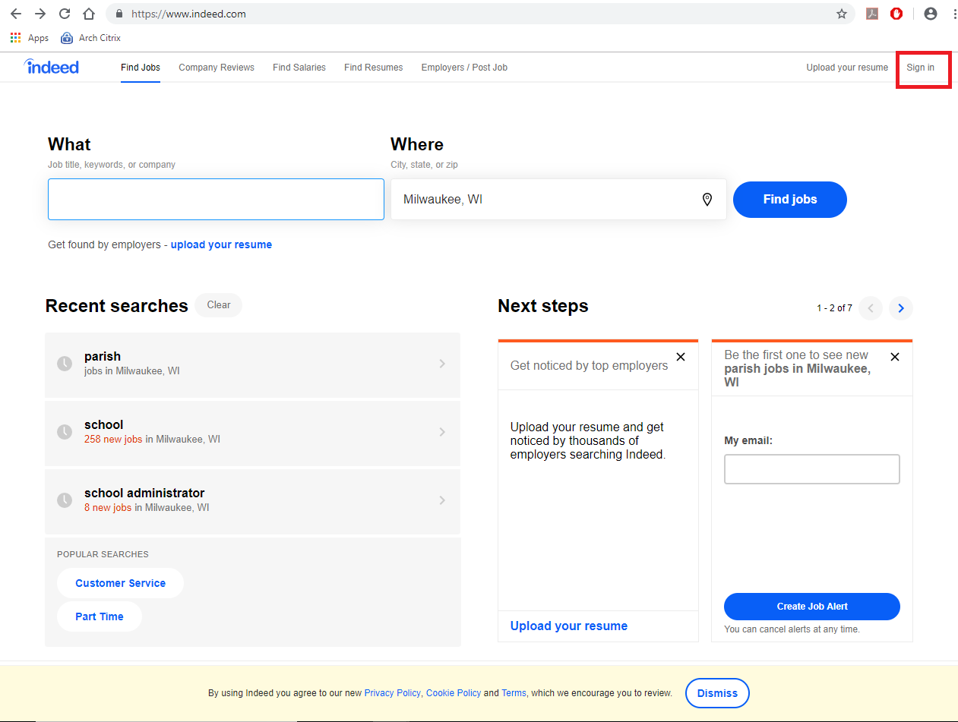
Indeed Account Setup

- Navigate to www.indeed.com.

- Select Sign in on the top right corner.

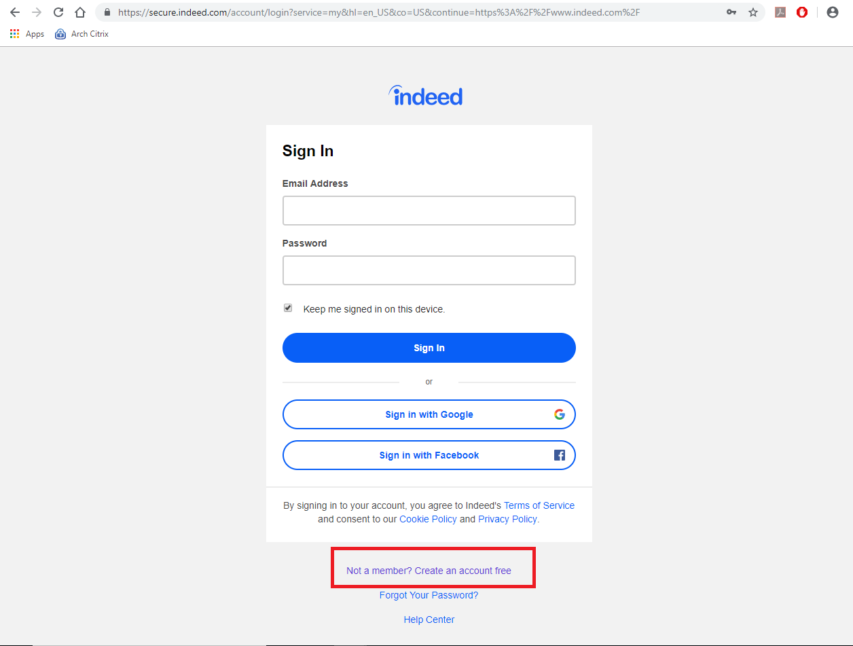

- Select: “Not a member? Create an Account free.”

- Select an email address and password for your account. Be sure to write them down and keep them in a secure location.

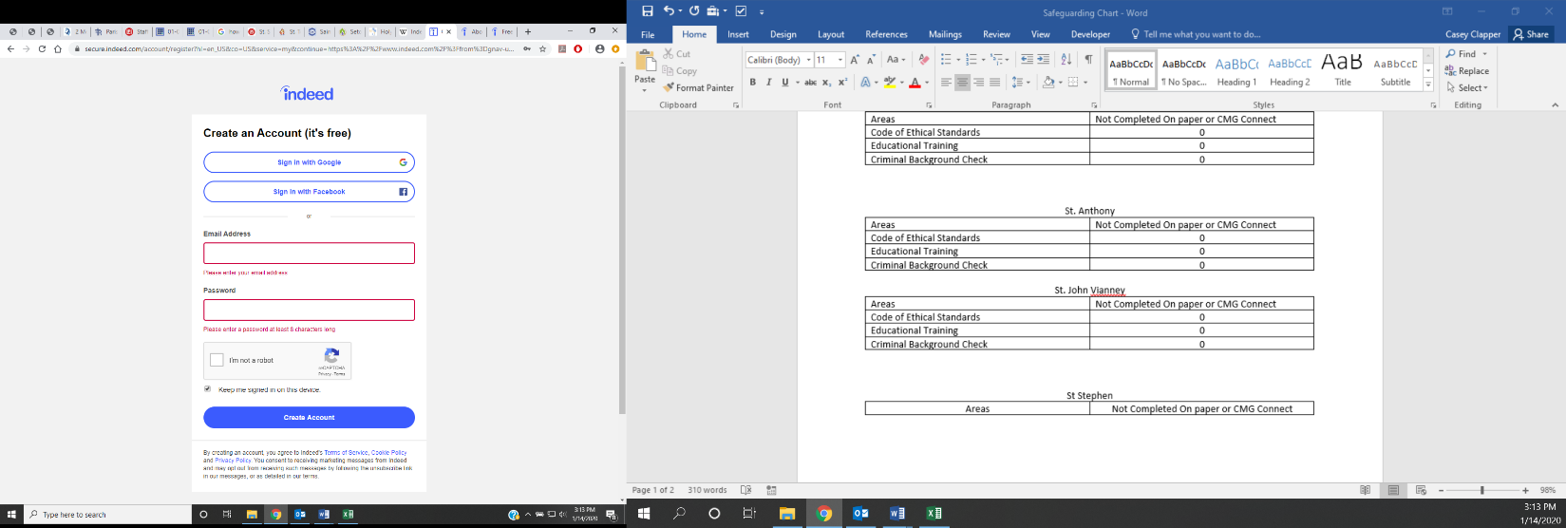
Note: You may be asked to confirm your account. In that case, go to the email that you used to sign up, and look for an email from indeed.com in your inbox. If it is not in the inbox, try your junk folders. If you cannot find your confirmation email, consult your IT administrator, as they may need to assist you in confirming your account.

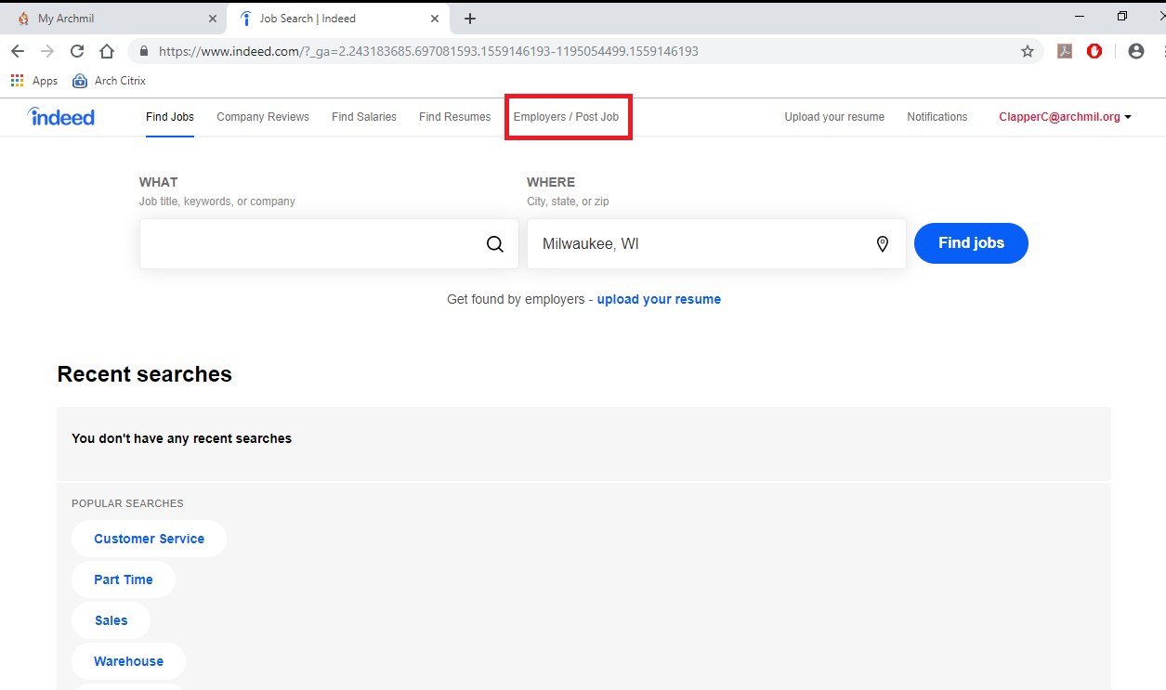

- Next, sign in. Select “Employers / Post Job”.

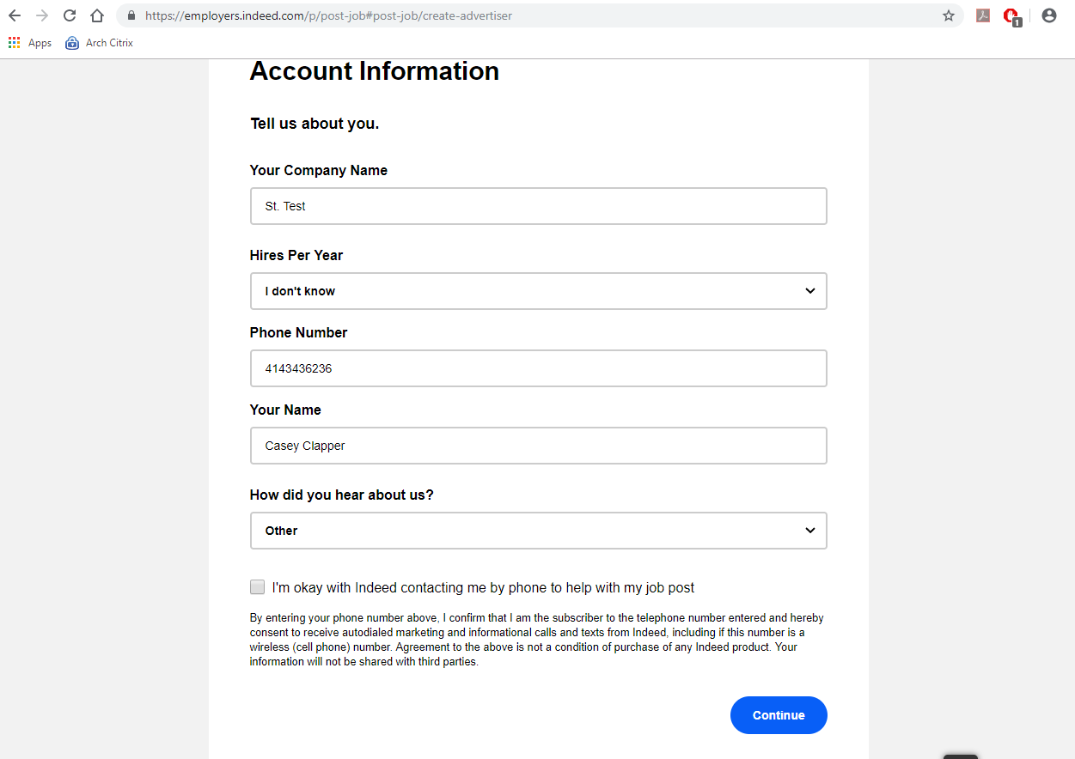

- Complete the other needed information. Answer them to the best of your ability. Here I will use some phony information to exemplify what your screen might look similar too.

Do NOT check the box indicating that you are ok with Indeed contacting you by phone. Indeed may try to call you to sell additional, unnecessary services. Click continue.

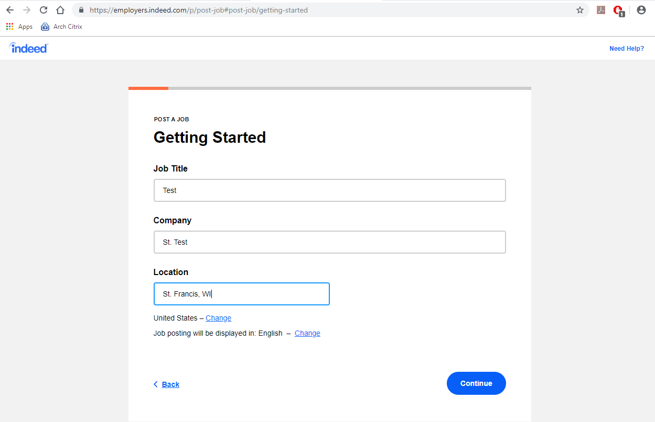

- Enter your title, company (parish/school name), and location on the getting started page.

Click continue.

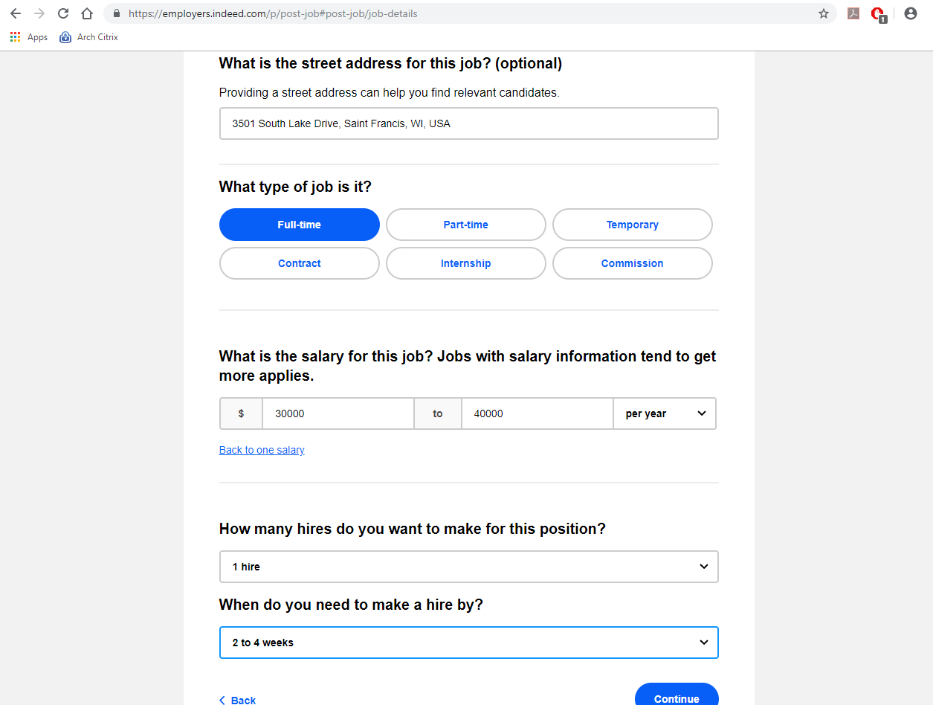
- Provide a street address, type of job, salary/wage (optional), how many hires you will be doing for this position, and when you would like to hire by on the Job Details page.

Click continue.

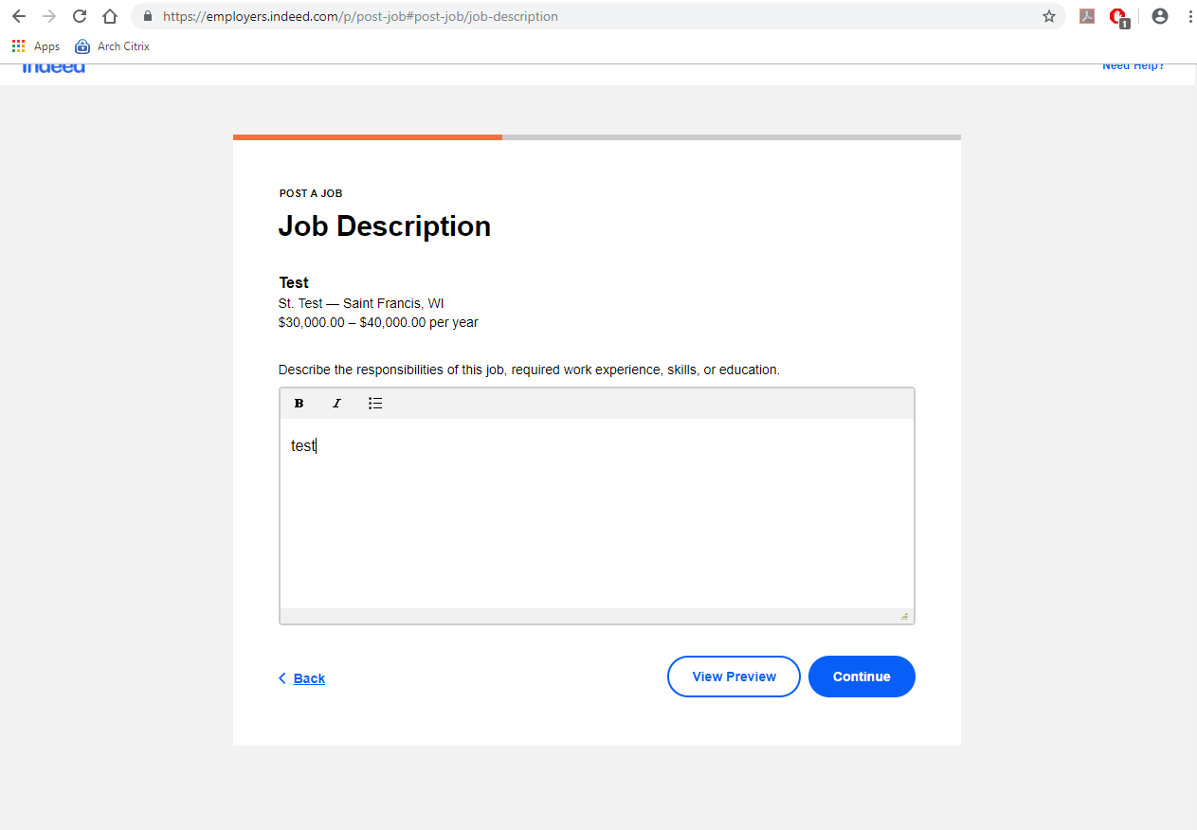

- Create a job description by cutting and pasting from your word processing document, i.e. Word. Fill in a brief but direct synopsis of the knowledge, skills, and responsibilities that may be required along with the responsibilities and duties of the role.

Click continue.

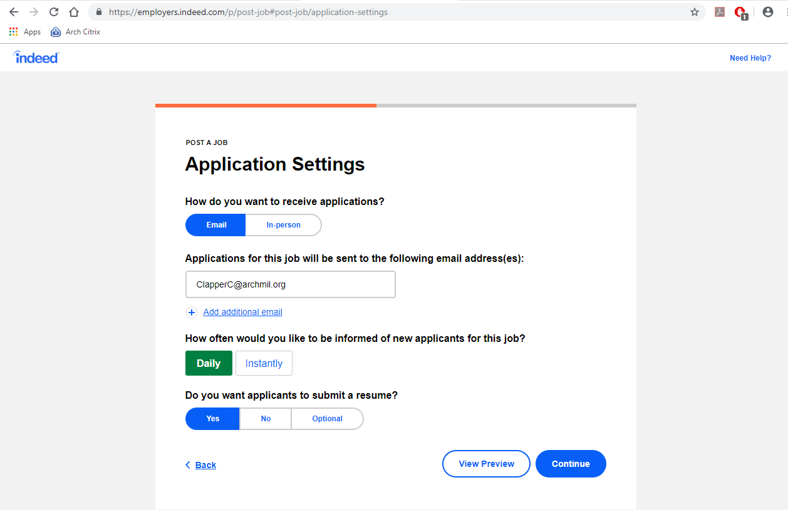

- On the application settings page, select how you want to receive applications. If by email (this is the default setting), then you will want to include the email of the hiring manager/indeed.com account user here. Indicate if you wish to be notified instantly of any new applicants or once a day. Finally, choose whether you want applicants to submit a resume.

Click continue.

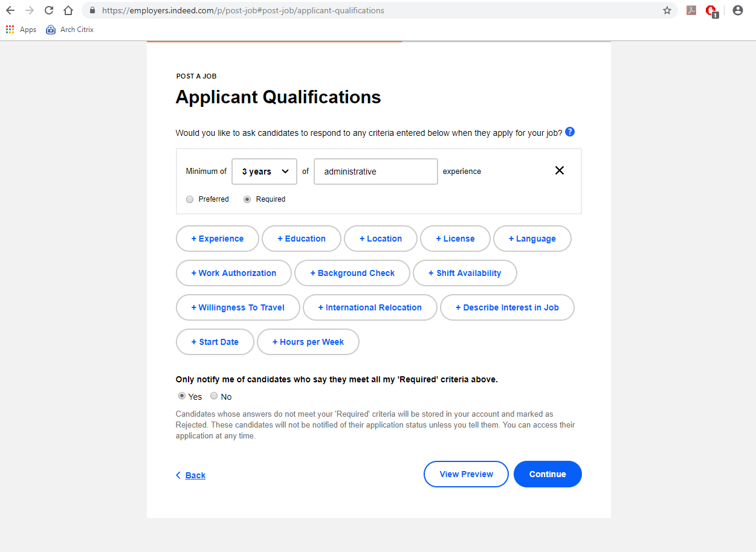
- On the applicant qualifications page, you have the opportunity to ask candidates to respond to a few questions in relation to certain requirements or preferences you might have for the position you are recruiting for. Click the + icon on the question you like to ask. For example, you might wish to ask a candidate about their years of experience. You might require that any candidate being considered have accrued 3 years of administrative experience. Therefore, you would want to click the required bubble, and add 3 years on the dropdown menu, and add “Administrative” in the open field. On the bottom, you can choose to only be notified of candidates that provide satisfactory answers to your questions if you so choose. Candidates whose answers do not meet your 'Required' criteria will be stored in your account and marked as Rejected. These candidates will not be notified of their application status unless you tell them. You can access their application at any time.

Note: We highly recommend selecting NO under this option. This is to ensure all candidates receive equal consideration, and that candidates who may not meet years of experience in your chosen keyword, but may be a fit based on educational or experience in a closely related field are not passed over without a review by the hiring manager.

You may view a preview of your posting by selecting “view preview”. If you are satisfied with your posting, click continue.
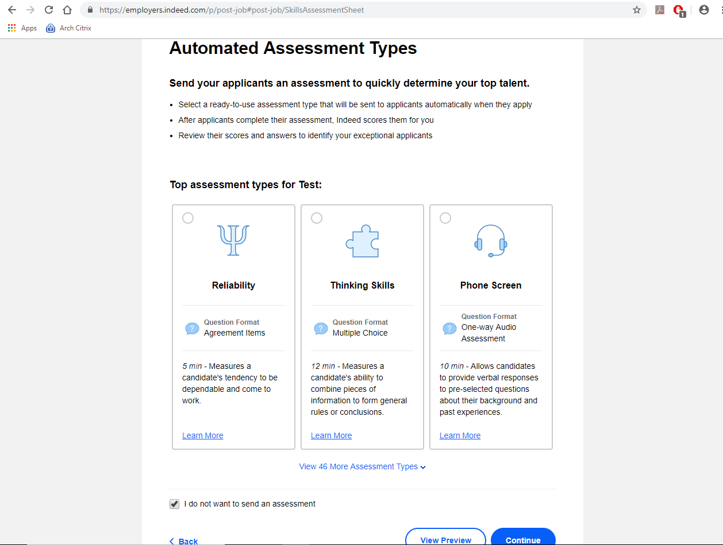

- Automated assessment types: Indeed offers a wide variety of automated assessments that job posters can require an applicant complete. However, keep in mind that in order to treat all candidates equally, candidates that apply for the role through other means must be asked to complete the same assessments. Therefore you are highly recommended to select “I do not want to send an assessment”. In most cases, it will be easier to rely on resume review and an interview to evaluate candidates.

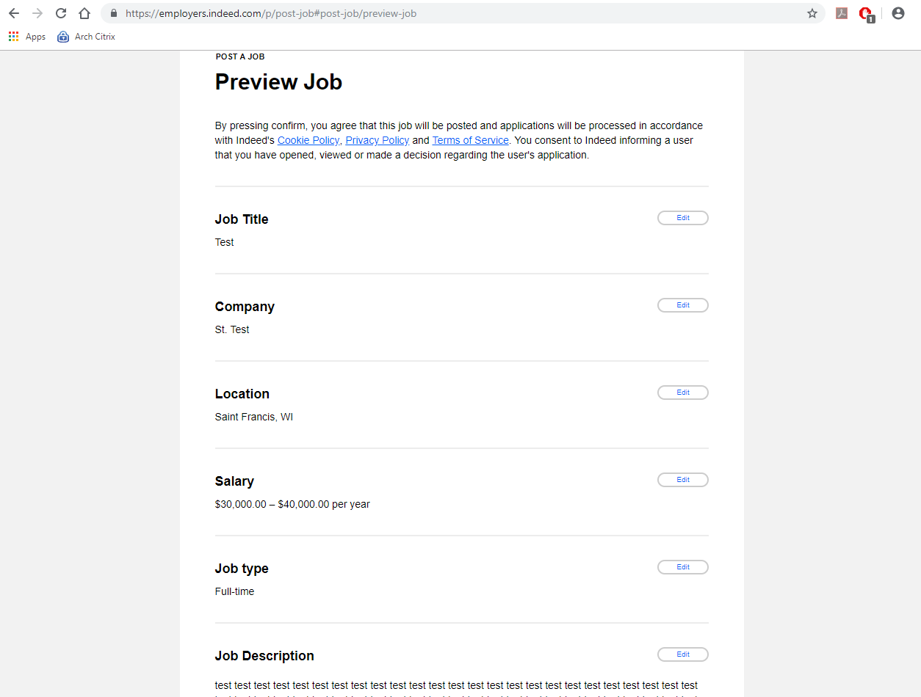

- Preview Job asks that you review all the settings that were discussed in previous steps. If all settings are appropriate and desired for the position that you are recruiting for, then press confirm to post your job.

Click continue.

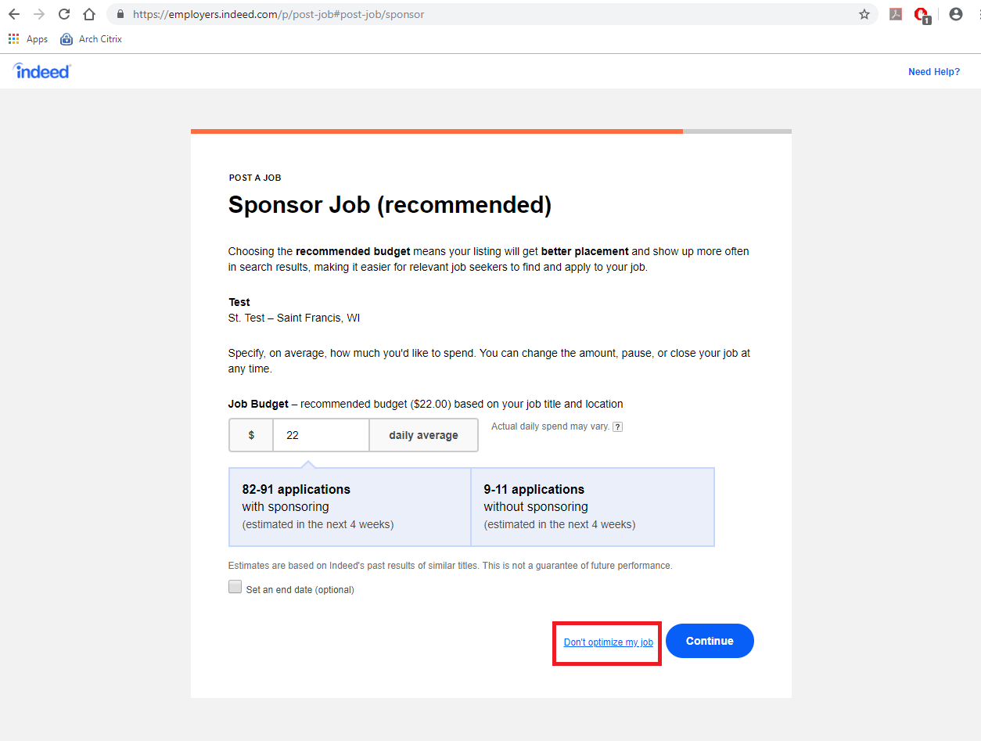
- Choose whether you wish to sponsor your job. Indeed’s sponsored ads work on a pay-per-click cost model. Sponsored ads receive a permanent spot at the top of the list of posts for the position you are posting. You pay a certain fee for every job seeker who “clicks” on your job post, which generally costs between $.25 cents and $1.50. The actual cost per click for your job posting varies based on competition for similar jobs in your area. In other words, sponsoring a post costs money, but is likely to get you more applicants and the posting will remain at the top of the list regardless of its age until the posting is filled. However, if you choose not to sponsor your job, the posting will be FREE. The only difference is that your post will start at the top of the page and fall down the list of competitors similar postings as new jobs are posted. To post without any cost, click “Don’t optimize my job”, boxed in red below.

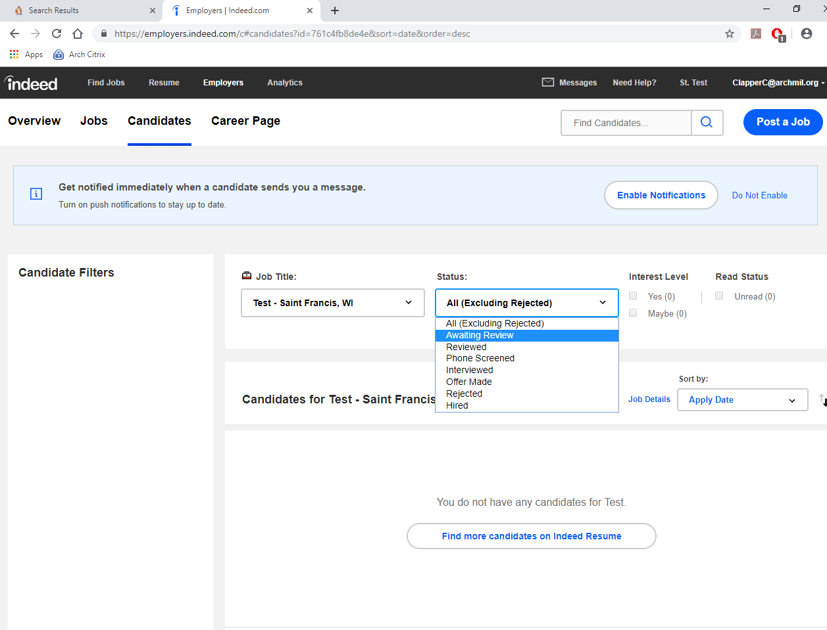
- Congratulations! You have now posted your job on Indeed. For now, sit back and wait for applicants to apply. You can review applicants by selecting the employers menu. Then, select candidates. Adjust the job title from the dropdown menu on the left (if multiple jobs posted at the same time under one account) and then the status from the dropdown menu on the right. From there, you can view all candidates which are awaiting review, or perhaps review candidates that you looked at already if you’d like a second look.

After-Post suggestions
Patience and careful re-evaluation is key for any post out on the web. It is not always clear why top candidates choose one role over another. If you find that your indeed.com post has not attracted the candidates with the right qualifications or experience, it may be worth re-examining your posting. Try to solicit feedback from others, such as the personnel committee (if one is available). It may be beneficial to go back to your job description and re-evaluate the requirements of the role. It may be that job description is too narrowly focused. It is possible that the post does not highlight what makes your organization such a great place to work. In any case, be patient, and be open to trying different approaches on indeed.com. You can always go back and delete your post, rewrite it and try again.

