Important Changes Coming

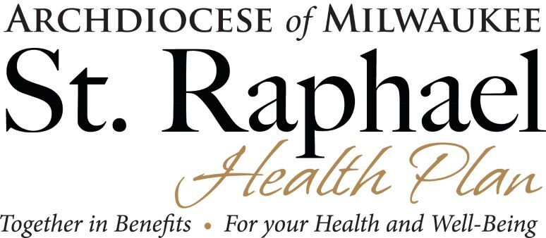

In keeping with our strategic plan to provide shared services to our parishes and schools, we will be moving the administration of the St Raphael Health Plan to a new platform —MyEnroll360 from Benefit Allocation Systems, LLC (BAS USA).

Benefit Allocation Systems is the owner and developer of MyEnroll360, which is a cloud-based insurance enrollment, billing, and communication system. Our goal in moving to this platform is to increase efficiencies in enrollment, billing, and communications for parishes and schools. As the developer of MyEnroll360, BAS USA does their own programming which enables them to customize the system to meet our needs now, and in the future, as we move additional benefits such as Life, AD&D, and other benefits to the platform.

We are currently implementing the transition which is scheduled to be completed by December 1 of this year. Our current administrator, Benefits Administration Services, Inc., has been notified of this change. As expected, they were very gracious and offered to help with the transition as needed. We are deeply grateful to them and to Lisa McGinnis in particular, for their partnership in administering the St. Raphael Health Plan over the past 11 years.

During this transition, you will continue to manage your benefits as you currently do. More information regarding this transition and eventual implementation on your end will follow in the coming weeks.

As always, thank you for your great work.

Together in Benefits for your Health and Well-Being,

Maureen Wurster
HR and Benefits Administrator
414-769-3423
wursterm@archmil.org

