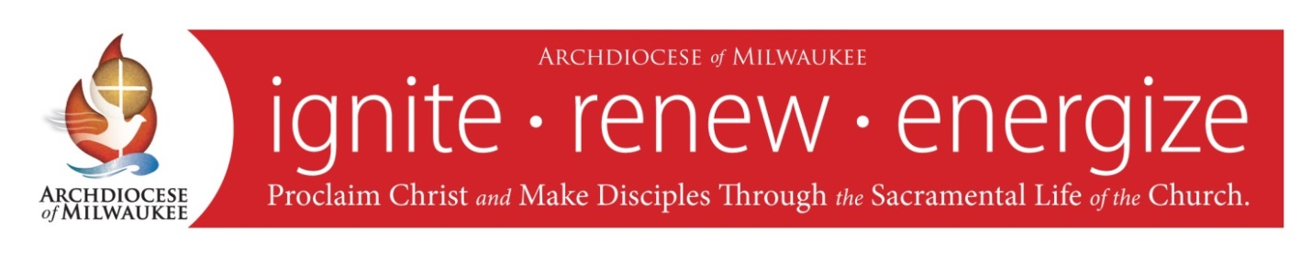

Prayer for the Mission of the
Archdiocese of Milwaukee

Almighty and ever living God,
we praise you and we bless you,
for you are great indeed!

Grant, we pray,
as on that first Pentecost,
that tongues of fire may descend upon us,
and that the driving wind of your Holy Spirit
may blow boldly into our hearts.

Loving God, we ask you,
make us effective and holy witnesses
of the death and resurrection
of your Son, Jesus Christ,
increase our faith
through the sacramental life of the Church,
grant us courage to follow you
as faithful disciples.
Embolden us, O God,
so that we may go forth to proclaim
your Gospel and renew the face of the earth.

In this Archdiocese of Milwaukee,
we humbly pray for strength and fortitude
to follow your great commission:
to go and make disciples of all people,
living our faith through word and deed.

Through the intercession of St. John the
Evangelist, patron of the archdiocese,
and Mary, Mother of the Church,
we ask all this through Christ our Lord.

Amen.

Printed with Ecclesiastical Permission

